Share Information with Other Subsystem Teams
In this activity, you will connect with other subsystems teams to determine what each subsystem needs to provide to other subsystems.
Task: Discuss and Record Subsystem Interface Needs
Instructions:
Use whatever tools and processes you feel are necessary to identify the needs for information sharing between subsystems. The tools at your disposal include data flow diagrams, N² charts, and CRC card exercises. Which tools you use will depend on the needs and habits of your team, or indeed if you are even working with a team. If you are designing the system on your own, you should use tools that you would feel comfortable using to talk through your system with your colleagues, a supervisor, or a client.
Step 1:
Document your understanding of the interfaces in your system, using either a data flow diagram, an N² chart, or both. Quite often it is discovered in this step that the information one subsystem is expecting to provide may not be complete enough or in the form most useful to another subsystem or vice versa. If you suspect this is the case, you may want to engage with others in a CRC card exercise. This discussion can help you define the information your subsystem needs to share as well as clarifying the needs of other subsystems.
Step 2:
Make notes on any unknowns or problem areas. This is commonly an iterative process, and you should not expect to fully realize all the interface elements on your first attempt. Often the interface documentation needs to evolve through discussion between teams and other ways of gathering information. That being said, you will be using this information later in the course, so make sure you are as thorough as you can be at this time.
This is Complete When...
This is Complete When...
You have coordinated with all the people working on all related subsystems (as needed) and have identified the information needs between the subsystems using a data flow diagram, an N² chart, or both.

Worked Example
Some of the tools you can use to help identify what information is needed between subsystems are:
- Data Flow Diagrams
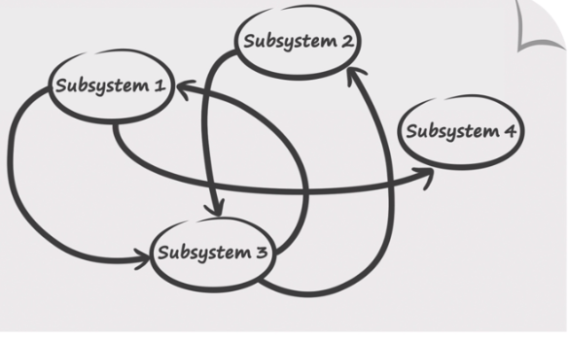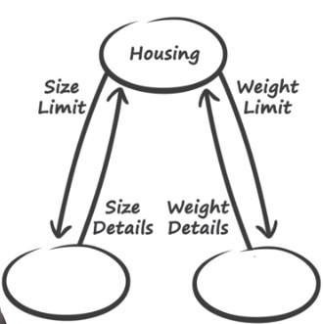
- N² Charts
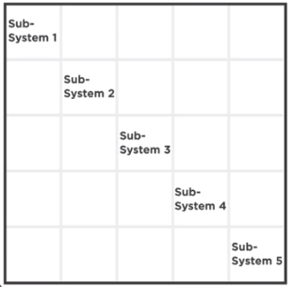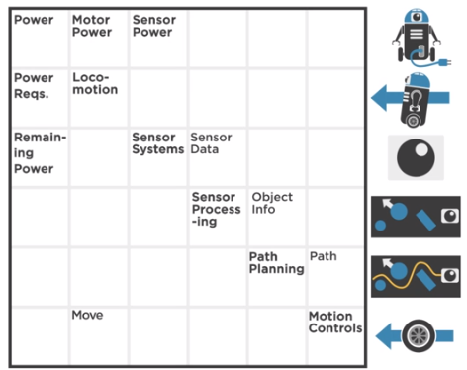
- CRC Cards
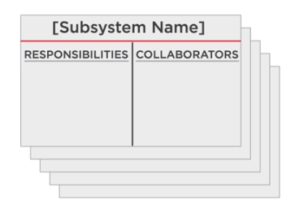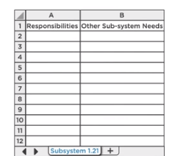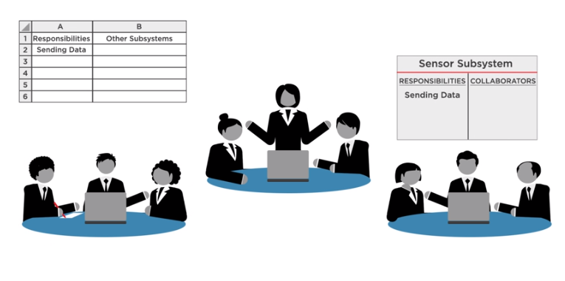
These tools will help you recognize whether the information provided by each subsystem to the other subsystems is sufficient. These tools will also help you identify each subsystem's responsibilities and specific needs.

